H.T No
Regulations:
A15

Sreenidhi Institute of Science and Technology
(An Autonomous Institution)
Code No: 5U202 Date: 23-Jan-2019 (FN)

M.Tech I-Year II-Semester End External Examination, Jan - 2019 (Supplementary)
CMOS ANALOG & MIXED SIGNAL DESIGN (VLSI & es)

Time: 3 Hours Max.Marks:75

Note: a) No additional answer sheets will be provided.
b) All sub-parts of a question must be answered at one place only, otherwise it will not be valued.
c) Missing data can be assumed suitably.

Part - A Max.Marks:25

Answer all QUESTIONS.

1. | What modifications should be taken for cascode current source to improve its output Voltage swing. | [3M]
2. | Write the advantages of negative feedback in amplifiers. | [3M]
3. | Explain the operation of Current Differential Amplifier with neat sketches. | [3M]
4. | Design High pass filter using Operational Transconductance Amplifier (OTA). | [3M]
5. | Implement Integrator using Switched Capacitor techniques. | [3M]
6. | What are the various specifications of DAC? Explain briefly. | [2M]
7. | Design a MOSFET – MOSFET voltage divider, so that the reference voltage is 2 volts, and the current through each MOSFET is 10 µA. | [2M]
8. | Draw the circuit diagram of Source Follower using active p-MOS transistor as load. | [2M]
9. | Discuss typical errors associated with sample and hold circuit. | [2M]
10. | Draw the circuit diagram of feedback amplifier which uses Voltage-Series topology and justify in your own words. | [2M]
Part – B Max.Marks:50
ANSWER ANY FIVE QUESTIONS. EACH QUESTION CARRIES 10 MARKS.

11. | a) | Mention the advantages of Band gap Voltage referenced biasing over other referenced biasing schemes. | [5M]
 | b) | Explain the principle of Band gap voltage reference to implement zero temperature coefficient of output reference voltage. | [5M]
12. | a) | Find the effect of negative feedback on input and output impedance’s of voltage amplifier. | [5M]
 | b) | An amplifier is characterized as  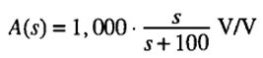  It is connected in a feedback loop with a variable β. Determine the variable β for which the low frequency roll off is 50 rad/sec. What is the value of closed loop gain at this point? | [5M]
13. | a) | Calculate slew rate and upper 3dB frequency of the Differential Amplifier circuit given.  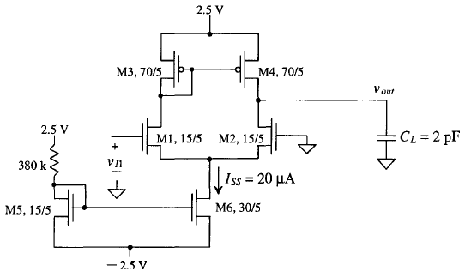 | [5M]
 | b) | Determine the input common mode range of n – channel Differential Amplifier with current source load. | [5M]
14. | a) | Draw the diagram of basic Operational Transconductance Amplifier and find its Transconductance. | [5M]
 | b) | Realize Low Pass Filter using Operational Transconductance Amplifier and also find the transfer function. | [5M]
15. | a) | Explain how the comparator is characterized by DC performance and transient  response. | [5M]
 | b) | Design a switch capacitor filter with the transfer function, which has a pole at 500 Hz and a zero at 5 kHz. The low frequency gain of the circuit is 20 dB. Use a lossy integrator. | [5M]
16. |  | Explain the following circuits :
 | a) | The Pipeline ADC | [5M]
 | b) | Charge Scaling DAC | [5M]
17. |  | Estimate the small signal gain, output impedance and frequency response of the amplifier shown. Assume both M1 and M2 are in Saturation region.  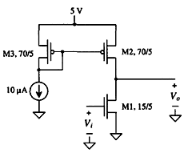 | [10M]

-- 00 -- 00 –

